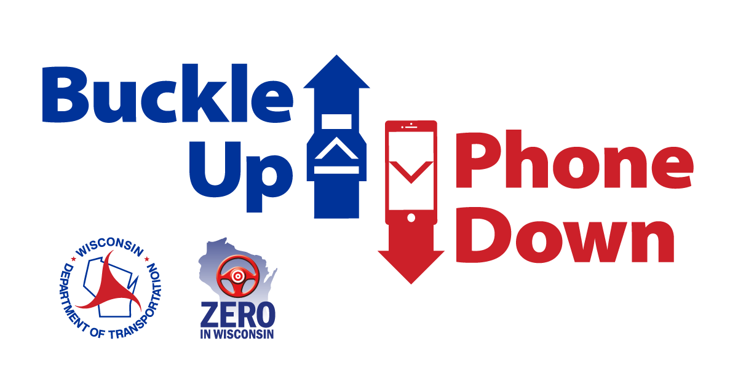

Buckle Up Phone Down talking points for partner organizations

- [BUSINESS/ORGANIZATION] is challenging our employees to buckle up and put their phones down every time they are driving a vehicle.
- [BUSINESS/ORGANIZATION] is working with the Wisconsin Department of Transportation to help reduce crashes and fatalities related to driver and passenger behavior.

- WisDOT’s Buckle Up Phone Down campaign is tackling the two most important actions a driver can take to prevent or survive a crash.

- Distracted driving is a leading cause of crashes in the United States. According to WisDOT, 31 people died in crashes related to distracted driving in Wisconsin in 2020.

- WisDOT reports 177 drivers and passengers who were not wearing seat belts died in crashes in 2020.

- The National Safety Council reports the number one cause of workplace fatalities is traffic crashes. Drivers, sales workers and truck drivers are the occupations with the highest number of fatalities. Source: NSC Injury Facts [link: https://injuryfacts.nsc.org/work/work-overview/work-safety-introduction/]
- The American Automobile Association reports texting while driving doubles the chances of being involved in a crash. Source: AAA 2018 crash risk analysis [link: https://aaafoundation.org/crash-risk-cell-phone-use-driving-case-crossover-analysis-naturalistic-driving-data/]

- Although many factors can help reduce deaths and serious injuries in a crash, the Buckle Up Phone Down campaign will encourage more people to wear their seat belt.
- Even the most attentive drivers can be involved in a crash caused by others. That’s why wearing a seat belt every time you get into a car becomes your best defense to stay safe.

- As part of the Buckle Up Phone Down Challenge, we will share “thumbs up/thumbs down” photos on social media to show support. Some images will be shared on WisDOT’s website: www.wisconsindot.gov/BUPD

