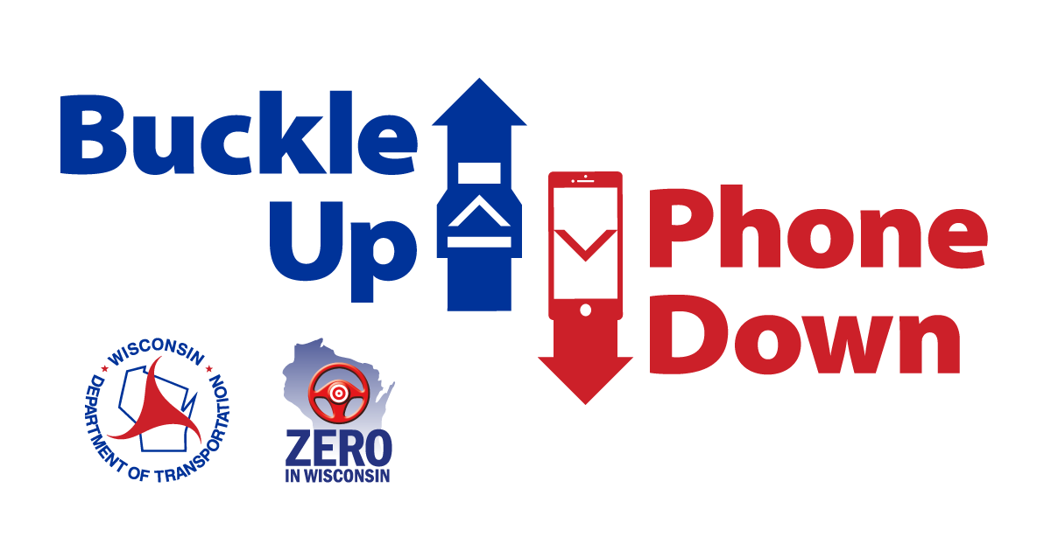

Buckle Up Phone Down talking points for partner organizations

- [BUSINESS/ORGANIZATION] is challenging our employees to buckle up and put their phones down every time they are driving a vehicle.
- [BUSINESS/ORGANIZATION] is working with the Wisconsin Department of Transportation to help reduce crashes and fatalities related to driver and passenger behavior.

- WisDOT’s Buckle Up Phone Down campaign is tackling the two most important actions a driver can take to prevent or survive a crash.

- Distracted driving is a leading cause of crashes in the United States. According to WisDOT, 40 people died in crashes related to distracted driving in Wisconsin in 2021.

- WisDOT reports 167 drivers and passengers who were not wearing seat belts died in crashes in 2021.

- The National Safety Council reports traffic crashes are a leading cause of workplace fatalities. Drivers, sales workers and truck drivers are the occupations with the highest number of fatalities. Source: NSC Injury Facts [link: https://injuryfacts.nsc.org/work/work-overview/work-safety-introduction/]
- The American Automobile Association reports texting while driving doubles the chances of being involved in a crash. Source: AAA 2018 crash risk analysis [link: https://aaafoundation.org/crash-risk-cell-phone-use-driving-case-crossover-analysis-naturalistic-driving-data/]

- Although many factors can help reduce deaths and serious injuries in a crash, the Buckle Up Phone Down campaign will encourage more people to wear their seat belt.
- Even the most attentive drivers can be involved in a crash caused by others. That’s why wearing a seat belt every time you get into a car becomes your best defense to stay safe.

- As part of the Buckle Up Phone Down Challenge, we will share “thumbs up/thumbs down” photos on social media to show support. Some images will be shared on WisDOT’s website: www.wisconsindot.gov/BUPD

