PLEDGE ANNOUNCEMENT FOR PARTICIPANTS
Customize this news release for your business, organization, school, or municipality. Consider adding a quote from your organization’s leader connecting Buckle Up Phone Down to your mission. Share the news release to announce your commitment to the campaign. Consider adding a “thumbs up/thumbs down” photo of your staff .
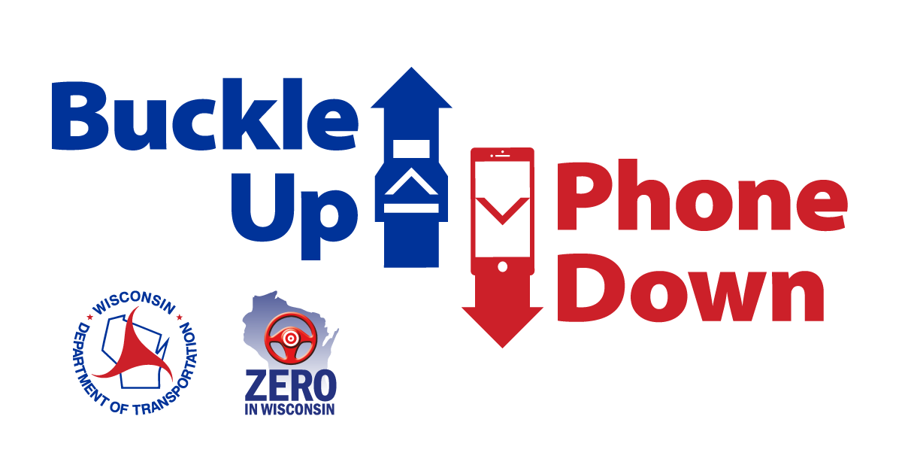

[ADD YOUR COMPANY’S LETTERHEAD]

Buckle Up Phone Down: A statewide challenge to keep Wisconsin’s roads safe
[YOUR BUSINESS NAME] is challenging our employees, customers, and partners to make a difference every time they get in the car: buckle up and put your phone down.

The Wisconsin Department of Transportation’s Buckle Up Phone Down campaign is tackling safety on the roads by targeting the two most important actions a driver can take to prevent or survive a crash. [BUSINESS/ORGANIZATION] is joining in the movement.

The first message of the campaign asks everyone to always buckle up. According to WisDOT, 50% of Wisconsin drivers and passengers who died in crashes in 2021 were not wearing a seat belt.

The campaign also urges drivers to put their phones down when they get behind the wheel. Distracted driving is a major cause of crashes across the United States and is on the rise in Wisconsin.

[BUSINESS/ORGANIZATION] is joining other Wisconsin organizations in supporting Buckle Up Phone Down to make sure employees stay safe while driving. We also hope to inspire people across the Badger state to do their part to prevent crashes in Wisconsin.

The Buckle Up Phone Down Challenge starts with businesses like ours, sharing videos and social media posts. Learn more on the WisDOT website: www.wisconsindot.gov/BUPD.

Join us in showing your support by taking a “thumbs up/thumbs down” photo and post it on social media using the hashtag #BuckleUpPhoneDown.
Together, we can make a difference and save lives.

