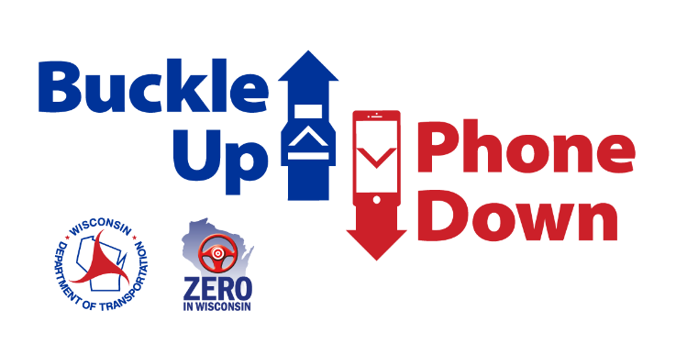

Suggested Buckle Up Phone Down social media posts
These social media posts are a customizable template for use after your business, organization, school, or municipality takes the pledge to join the campaign. Share similar messages to encourage followers to take on the challenge as an individual. Include your “thumbs up/thumbs down” photos, or videos explaining why your organization’s leaders are taking the pledge.

Facebook
- [Business/Organization] is joining the Wisconsin’s Buckle Up Phone Down campaign that challenges people to take simple action to stay safe while driving. As a business, we’re making sure our employees are always buckling up and never texting while driving. Join us to eliminate dangers on the roads. #BuckleUpPhoneDown

- We took the pledge, will you?
[Business/Organization] employees promise to always buckle up and put the phone down in the car. We’re joining the Wisconsin Department of Transportation’s Buckle Up Phone Down campaign and hope you do, too. Take the pledge here: www.wisconsindot.gov/BUPD #BuckleUpPhoneDown

- Traffic crashes are the number one cause of workplace deaths, according to the National Safety Council. That’s why [Business/Organization] is taking the Buckle Up Phone Down pledge to make sure our employees are safe on the roads. Please take on the challenge in your cars, too. #BuckleUpPhoneDown

Twitter

- We challenge you to #BuckleUpPhoneDown. [Business/Organization] is joining the @WisconsinDOT campaign to prevent injuries and deaths on the roads. Take the pledge yourself here: www.wisconsindot.gov/BUPD
- Buckling your seat belt is the best way to survive a crash. @WisconsinDOT reports 167 people who died in crashes in 2021 weren’t buckled up. Take the pledge with us. #BuckleUpPhoneDown
- Distracted driving is on the rise in WI. @WisconsinDOT reports more than 10,000 crashes involved distracted drivers in 2021. Don’t be a statistic. Join [Business/Organization] in preventing crashes by committing to #BuckleUpPhoneDown

