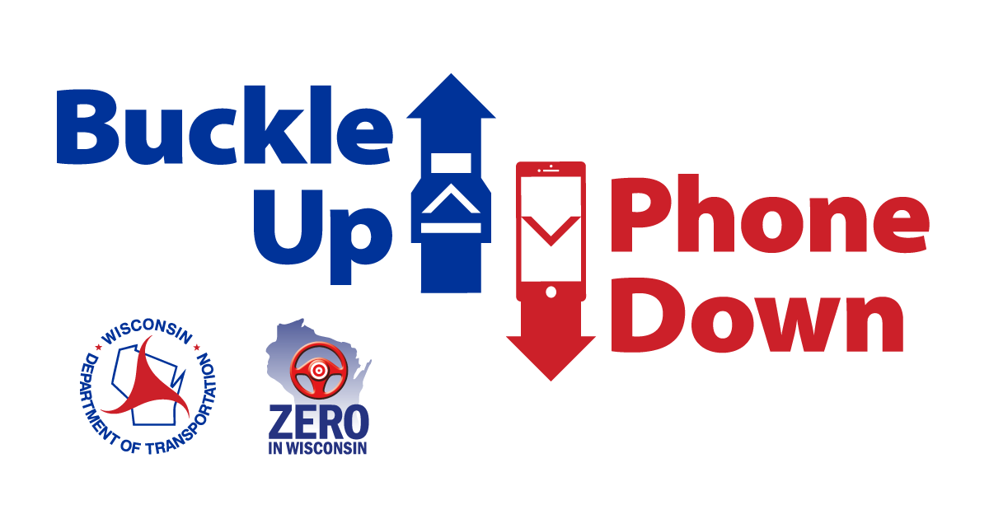

**Buckle Up Phone Down talking points for partner organizations**

* **[BUSINESS/ORGANIZATION]** is challenging our employees to buckle up and put their phones down every time they are driving a vehicle.
* **[BUSINESS/ORGANIZATION]** is working with the Wisconsin Department of Transportation to help reduce crashes and fatalities related to driver and passenger behavior.
* WisDOT’s Buckle Up Phone Down campaign is tackling the two most important actions a driver can take to prevent or survive a crash.
* Distracted driving is a leading cause of crashes in the United States. According to WisDOT, 23 people died in 9,261 crashes related to distracted driving in Wisconsin in 2023.
* WisDOT reports 142 drivers and passengers who were not wearing seat belts died in crashes in 2023.
* Although many factors can help reduce deaths and serious injuries in a crash, the [Buckle Up Phone Down](https://www2.modot.org/BuckleUpPhoneDown/) campaign will encourage more people to wear their seat belt.
* Even the most attentive drivers can be involved in a crash caused by others. That’s why wearing a seat belt every time you get into a car becomes your best defense to stay safe.
* As part of the Buckle Up Phone Down Challenge, we will share “thumbs up/thumbs down” photos on social media to show support. Some images will be shared on WisDOT’s website: [www.wisconsindot.gov/BUPD](http://www.wisconsindot.gov/BUPD)