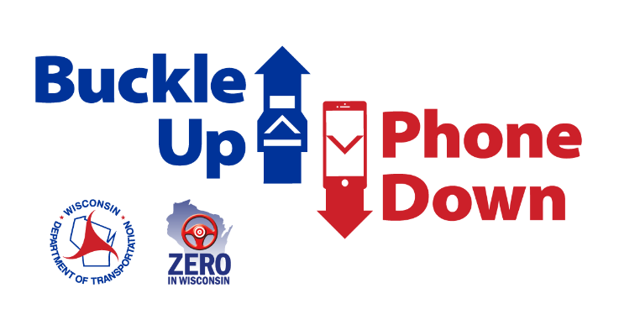

**Suggested Buckle Up Phone Down Day social media posts**

After you or your organization takes the Buckle Up Phone Down Day challenge, here are some sample social media posts you can use for Buckle Up Phone Down Day on Oct. 30, 2024. Feel free to include a photo of you and/or your team doing our "right thumb up, left thumb down" hand gesture in your post. If you'd like to create your own post, please tag us and use the hashtag #BuckleUpPhownDown.

**Tag us!**

* **Instagram –** @wisdot
* **Facebook –** @Wisconsin Department of Transportation
* **X/Twitter –** @WisconsinDOT

**Template Posts**

* We accepted the challenge to always put our seat belts on before getting on the road and always keep our phones out of reach when driving. Join us today on Buckle Up Phone Down Day! Help save lives by taking the @WisDOT #BuckleUpPhoneDown challenge: [www.wisconsindot.gov/BUPD](http://www.wisconsindot.gov/BUPD)
* Today is #BuckleUpPhoneDown Day! @WisDOT challenged us to put safety first by taking the two most important actions to prevent or survive a crash: buckling up and putting our phones down on the road. Join the movement at: [www.wisconsindot.gov/BUPD](http://www.wisconsindot.gov/BUPD)
* Today is #BuckleUpPhoneDownDay, we took the challenge and so should you! Together we can create positive change in driver behavior and create safer roads. Crashes, injuries and deaths related to distracted driving and seat belt use are preventable! Go to: [wisconsindot.gov/BUPD](http://www.wisconsindot.gov/BUPD)