PLEDGE ANNOUNCEMENT FOR PARTICIPANTS
Customize this news release for your business, organization, school, or municipality. Consider adding a quote from your organization’s leader connecting Buckle Up Phone Down to your mission. Share the news release to announce your commitment to the campaign. Consider adding a “thumbs up/thumbs down” photo of your staff.
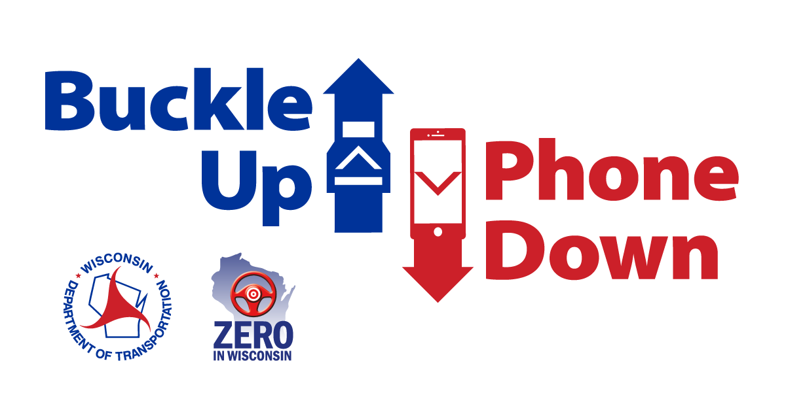

[ADD YOUR COMPANY’S LETTERHEAD]

Buckle Up Phone Down: A statewide challenge to keep Wisconsin’s roads safe
[YOUR BUSINESS NAME] is challenging our employees, customers and partners to make a difference every time they get in the car: buckle up and put your phone down.

The Wisconsin Department of Transportation’s Buckle Up Phone Down campaign is tackling safety on the roads by targeting the two most important actions a driver can take to prevent or survive a crash. [BUSINESS/ORGANIZATION] is joining in the movement.

The first message of the campaign asks everyone to always buckle up. According to WisDOT, 53 percent of Wisconsin drivers and passengers who died in crashes in 2024 were not wearing a seat belt.

The campaign also urges drivers to put their phones down when they get behind the wheel. Distracted driving is a major cause of crashes across the United States and in Wisconsin. In 2024, distracted driving was a factor in 9,068 crashes and 44 fatalities.

[BUSINESS/ORGANIZATION] is joining other Wisconsin organizations in supporting Buckle Up Phone Down to make sure employees and other road users stay safe while driving. We also hope to inspire people across the state to do their part to prevent crashes in Wisconsin.

Join us in showing support for the Buckle Up Phone Down campaign by accepting the challenge at www.wisconsindot.gov/BUPD and sharing a “thumbs up/thumbs down” photo on social media using the hashtag #BuckleUpPhoneDown.
Together, we can make a difference and save lives.

