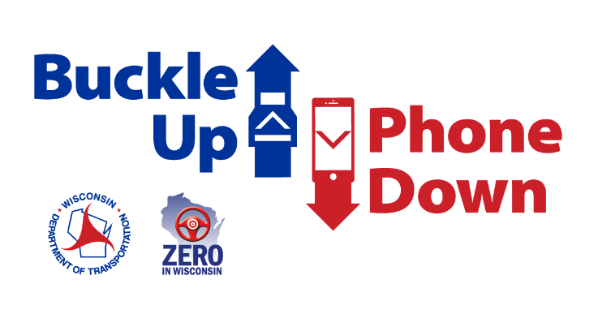

Suggested Buckle Up Phone Down Day social media posts

Thanks for taking the Buckle Up Phone Down challenge and committing to safer roads.

Buckle Up Phone Down Day is on Wednesday, October 29, 2025. It’s an opportunity to spread awareness of the lifesaving impact of these two simple actions.

Sample Buckle Up Phone Down Day social media posts are provided below. Feel free to include a photo of yourself and/or your team doing the "right thumb up, left thumb down" Buckle Up Phone Down hand gesture. Be sure to tag the Wisconsin Department of Transportation and use the hashtag #BuckleUpPhownDown.

Tag us!

- Instagram – @wisdot
- Facebook – @Wisconsin Department of Transportation
- X/Twitter – @WisconsinDOT

Template Posts

- We (I) accepted the challenge to always wear a seat belt and put our phone down when driving. Join us today on Buckle Up Phone Down Day! Help save lives by taking the @WisDOT #BuckleUpPhoneDown challenge: www.wisconsindot.gov/BUPD

- Today is #BuckleUpPhoneDown Day! @WisDOT challenged us to put safety first by taking the two most important actions to prevent or survive a crash: buckling up and putting our phones down behind the wheel. Take the Buckle Up Phone Down pledge: www.wisconsindot.gov/BUPD

- Today is #BuckleUpPhoneDownDay! We took the challenge and so should you. Together we can make a positive change in driver behavior and create safer roads. Crashes related to distracted driving are preventable and seat belts save lives. Go to: wisconsindot.gov/BUPD

